Real-World Measurement of Equilibrium Constants

Chemistry textbooks make the determination of equilibrium constants sound easy: Measure the concentrations of all species in a solution, then use the appropriate formula. What the textbooks gloss over is that fact that there is no universal “concentration meter” that can measure the concentration of an arbitrary molecule. Specialized tests must be developed for each molecule. As a result of this complication, equilibrium constants are typically determined by a combination of clever measurements and calculations as illustrated by this experiment.

You will measure the equilibrium constant for the reaction of Fe3+ and SCN–, the thiocyanate ion, to form the iron (III) thiocyanate complex FeSCN2+,

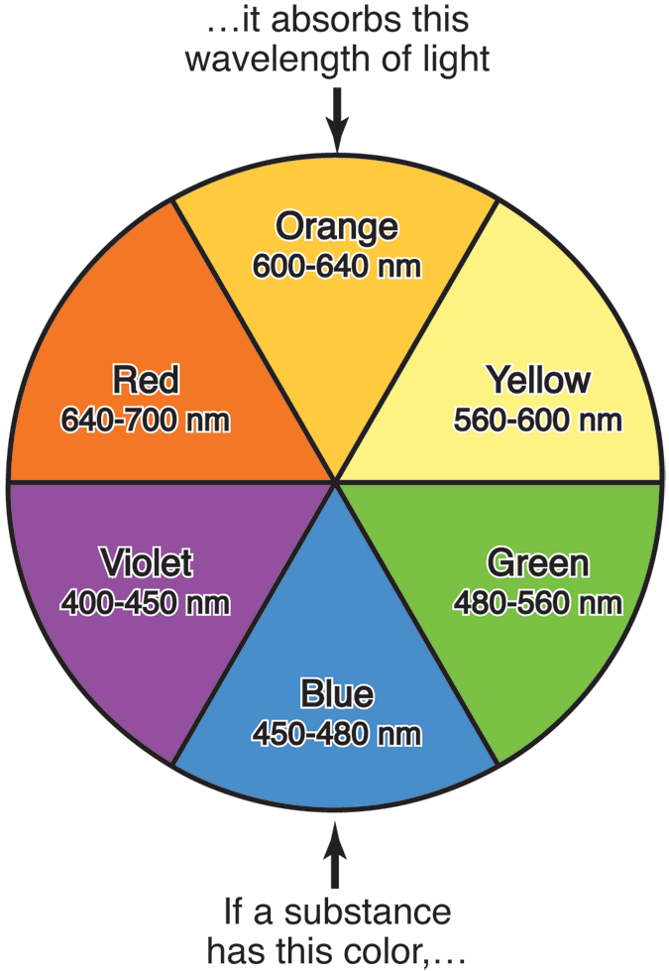

Fig. 1: A color wheel summarizes the relationship between the perceived color of a substance and the color of light that it absorbs, which is the complementary color. The approximate wavelengths of the colors are also listed.



Fig. 2: The visible spectrum of a solution of dye molecules.

  

Your analysis will be based on the fact that FeSCN2+ is brightly colored, whereas the other two species are (nearly) colorless. You will measure the concentration of FeSCN2+ in a solution by quantitatively comparing the color of that solution to the color of a solution of known concentration. The process of quantitatively comparing colors is known as *spectroscopy*.

The visible color of a solution can be quantified by measuring the colors of light that solution absorbs, its *absorbance,* using a visible spectrometer. For example, if a solution appears yellow in white light (*i.e.* normal room light), the solution must be selectively *absorbing* non-yellow light. This implies that the solution is *absorbing* the complementary color of yellow, which is violet. On a visible spectrometer, this solution would be expected to have a maximum absorbance in the violet range, which corresponds to wavelengths of ~400-450 nm. Figure 1 summarizes the relationship between the color of light, its wavelength, and its complement.

Most molecules absorb a range of wavelengths, not a single wavelength (color) of light. Figure 2 shows the *visible spectrum* of a dye solution — the *absorbance* of the solution as a function of wavelength. Absorbance is measured in “absorbance units,” typically abbreviated “A. U.” An absorbance of 1.0 means that 10% of the incident light is absorbed.[1] Higher absorbance is associated with more light absorption; lower absorbance with less light absorption. The molecule in Fig. 2 absorbs a significant fraction of the light at 430 nm (blue light), but almost none of the light at 610 nm (orange light).

So what is the color of this molecule? Figure 1 shows that molecules that absorb blue light appear orange. Since there are no other strong absorptions, a solution of the molecule will be orange.

Chemists use visible spectrometers to quantify color and to relate color to concentration. (“Visible” denotes the wavelength range measured. Infrared and ultraviolet spectrometers are also used.) The spectrum in Fig. 2 was measured on a visible spectrometer. The solution in Fig. 2 has a maximum absorbance at 430 nm of 1.266. If the concentration of this molecule decreased by a factor of two, the absorbance at 430 nm (or at any wavelength) would also decrease by a factor of two. The new absorbance would thus be 1.266/2 = 0.633. Because of this, the absorbance reading (*i.e.*, the quantitative color) can be used to measure *relative concentrations* of colored solutions using

  

where *A1*() is the absorbance of a solution of some species at concentration *c1* at wavelength , and *A2*() is the absorbance of the same species at a concentration *c*2 at the same wavelength . (This equation assumes that solutions of the same thickness are measured. This is not a problem, as most spectrometers use liquid sample holders, or *cuvettes,* of a specific size.)

Chemists often make measurements at the wavelength of maximum absorbance because measurements at this wavelength have the highest signal-to-noise ratio. There is nothing special about this wavelength, though, and measurements at 400 or 450 nm (in Fig. 2) would be almost as accurate. The important point is that *all measurements must be made at the same wavelength.*

Another example will help to illustrate the use of Eqn. (2). Suppose that a 0.150 M solution of green food coloring has an absorbance of 0.198 at a wavelength of 670 nm. If you are given a second solution which has a measured absorbance of 0.085 also at 670 nm, the concentration of the second solution must be

 

Whither the Known Concentration?

Spectroscopy can be used to find the relative concentrations of two solutions, but this experiment requires exact concentrations, not relative concentrations. We need a calibration solution of known FeSCN2+ concentration. But how can we make this solution if FeSCN2+ spontaneously dissociates into Fe3+ and SCN– according to Rxn. (1)?

The answer to this conundrum lies in Le Châtelier’s Principle. If a large excess of SCN– is added to the solution, we can make the assumption that the vast majority of the iron in solution will be in the form of FeSCN2+.

The Power of Serial Dilutions

In principle, an equilibrium constant can be calculated from measurements of one specific solution, but no chemist would actually do that. At least two measurements are necessary to show that a constant is indeed constant!

To prove that an equilibrium constant is constant, measurements must be made over a wide range of concentrations. In this experiment, you will make measurements over a wide range of initial [Fe3+] while keeping initial [SCN–] constant.

One of the most effective ways to cover a wide range of concentrations with a few measurements is to use a *serial dilution*. Starting with a stock solution, each successive solution is diluted by the same factor. For example, if you start from a 1.0 M solution and make each successive solution one third of the concentration of the previous solution, you will generate solutions with concentrations of {1.0 M, 0.33 M, 0.10 M, 0.033 M, 0.010 M, …} As shown by the graph in Fig. 3, this process results in an exponential decay. In the case of dilutions by one third, you cover three orders of magnitude in concentration with only 5 solutions!

Fig. 3: The result of a 1/3 serial dilution of an initially 1.0 M solution on both linear (top) and logarithmic (bottom) scales. The dotted line is an exponential fit.



The challenge with serial dilutions is accuracy, as errors in one solution are carried through to all successive solutions. Because of this, serial dilutions are always made using *volumetric techniques* (*e.g.,* a volumetric pipette and a volumetric flask), never with graduated cylinders.

Volumetric glassware is incredibly accurate and precise *if used correctly.* For example, a typical 10 ml volumetric pipette is accurate to ±0.02 ml (0.2% error!), yet costs about $8.50. A typical 25 ml volumetric flask is accurate to ±0.03 ml (but costs about $67!) A 10/25 dilution can therefore be made with only 0.2% error, and a solution that is made from 5 successive volumetric dilutions should have only 1% error.[2]

Correct pipetting technique is best learned by example. Before coming to lab, please study the volumetric pipetting video posted on the Chem 2080 Blackboard site. (There are many YouTube videos purporting to show correct pipetting technique. Most of these are either incorrect, use a different style of bulb, or both. Watch this one.)

In contrast, volumetric flasks are much more straightforward to use if you understand their one drawback: mixing a solution in a volumetric flask is quite inefficient. For the dilution of liquids, sufficient accuracy can often be obtained by inserting the glass stopper and inverting the flask 5 times, letting the air bubble rise completely to the top on each inversion. Be aware that solutions made in small volumetric flasks (10 ml and smaller) can be quite difficult to mix thoroughly.

The correct procedure for a serial dilution of an aqueous solution with a 10 ml pipette and a 25 ml volumetric flask is

1. Put initial solution into a clean, *dry* beaker.

2. Pipette 10 ml (actually, 10.00 ml!) of the initial solution into a clean (*possibly wet*) volumetric flask.

3. Add sufficient distilled H2O to the flask until the bottom of the solution meniscus reaches the calibration mark.

4. Cap the flask, then invert at least 5 times.

5. Pour the new solution into a clean, *dry* beaker.

6. Repeat steps 2-6 until all solutions are made.

This procedure assumes that you have a large stock of clean, dry beakers. You, on the other hand, will have to make judicious use of your glassware — disposing of solutions, washing, and drying as necessary.

Experiment

You will have one lab period to design and perform experiments to determine the equilibrium constant of Rxn (1). Use the following general procedure.

1. Clean six 150-mm-long test tubes. Rinse the tubes thoroughly with distilled water and flame dry them. Label the test tubes 1 through 6. Do not create pain for yourself and paperwork for all of us by burning yourself on the now-hot test tubes‼

2. Use a volumetric pipette to transfer 5 ml of stock KSCN solution to each test tube.

3. Use a volumetric pipette to transfer 5 ml of stock Fe(NO3)3 solution to test tube 1. Stir well.

4. Using serial dilution techniques with a 10 ml pipette and a 25 ml volumetric flask, add 5 ml of serially diluted Fe(NO3)3 solution to test tubes 2-6. Stir the solutions well. In the end, your test tubes should contain



5. Using the visible spectrometer, measure the spectrum of your most concentrated solution. Decide which wavelength you will use for your concentration determination, and record this wavelength in your notebook. Instructions for operating the spectrometer are posted in the lab.

6. Measure the absorbances of your 6 solutions at your chosen wavelength. Record these measurements in your notebook.

Available Equipment and Reagents

You may use any equipment in your lab drawer in addition to the following items:

2.0 × 10–4 M KSCN (*aq*)

0.20 M Fe(NO3)3 (*aq*)

5 ml volumetric pipette

10 ml volumetric pipette

25 ml volumetric flask

Distilled water

Safety Considerations

If the solutions come in contact with your skin, rinse the affected areas under running water.

Waste Disposal

All chemical waste generated during the experiment should be flushed down the sink with water.

Laboratory Report

All lab reports must be written individually. Data that are recorded as a group should be attributed in the lab report to all members of the group. Data that are recorded by a specific group member and shared with the group must be explicitly attributed to the group member who did the work. All text, tables, and figures in your lab report should be prepared by you; copying these materials from another student or sharing your materials with another student is a violation of the Cornell Code of Academic Integrity.

Your report should have a cover sheet and should contain an abstract that summarizes your major conclusions, an experimental section, and a results and discussion section. Your experimental section must contain a *complete* description of your experimental procedure. State your analysis wavelength and explain your rationale for this choice. Any Chem 2080 student should be able to reproduce your experiment after reading your lab report. This section does not have to be long, but it must be complete. The results and discussion section should contain a table that summarizes your experimental measurements. The section should also contain any equations or graphs used for the determination of the equilibrium constant. Discuss potential sources of experimental error. In particular, do you think the presence of the pale yellow Fe3+ ion affected your measurements? Why or why not? If possible, suggest improvements to your procedure.

1. Absorbance is not linearly proportional to the amount of light absorbed; it is a logarithmic relationship, as will be discussed in more advanced experimental chemistry courses.
2. The calculation of propagated errors is beyond the scope of this course, so don’t worry about the error calculations.